**API Documentation: Managing Job Openings**

The Job Openings REST API demonstrates the API Builder capabilities using an imaginary e-commerce platform. It provides endpoints for managing job openings, I.e., for retrieving items/jobs and their details as well as adding/updating job details to a database.

**Getting Started**

Make sure to update the connectionString value to correct server and database details where the database is created/restored. (update connectionStrings in App.config and Web.config files in app solution)

Refer to API Help page from WebAPI App (after running the application) while referring to web APIs mentioned below:

Example/Sample link: <https://localhost/Help>

Reference Screenshot:

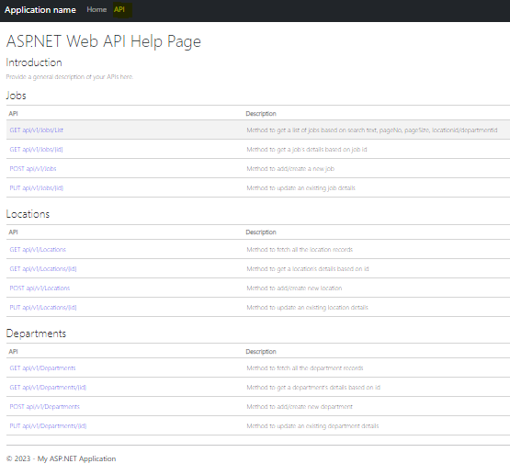

**Masters APIs**

1. **Departments Module**

* **GET: api/v1/Departments**

- Method to fetch all the department records

|  |  |
| --- | --- |
| **Request Information** | |
| URI Parameters | None |
| Body Parameters | None |

|  |  |
| --- | --- |
| **Response Information** | |
| Status | 200 OK |
| Body | Sample JSON response:  [      {          "Id": 1,          "Title": "Software Development"      },      {          "Id": 2,          "Title": "Project Management"      }  ] |

* **POST: api/v1/Departments**

- Method to add/create new department

|  |  |
| --- | --- |
| **Request Information** | |
| URI Parameters | None |
| Body Parameters | Sample JSON request:  {    "Title": "Test Department"  } |

|  |  |
| --- | --- |
| **Response Information** | |
| Status | 201 Created |
| Body | https://localhost/api/v1/Departments/11 |

* **PUT: api/v1/Departments/{id}**

- Method to update an existing department details

|  |  |
| --- | --- |
| **Request Information** | |
| URI Parameters | id (type int, required) |
| Body Parameters | Sample JSON request:  {    "Title": "Test Dept 2"  } |

|  |  |
| --- | --- |
| **Response Information** | |
| Status | 200 OK |
| Body | OK |

1. **Locations Module**

* **GET: api/v1/Locations**

- Method to fetch all the location records

|  |  |
| --- | --- |
| **Request Information** | |
| URI Parameters | None |
| Body Parameters | None |

|  |  |
| --- | --- |
| **Response Information** | |
| Status | 200 OK |
| Body | Sample JSON response:  [      {          "Id": 1,          "Title": "US Office",          "City": "Baltimore",          "State": "MD",          "Country": "United States",          "Zip": 21202      },      {          "Id": 2,          "Title": "India Head Office",          "City": "Bangaluru",          "State": "Karnataka",          "Country": "India",          "Zip": 560030      },  ] |

* **POST: api/v1/Locations**

- Method to add/create new location

|  |  |
| --- | --- |
| **Request Information** | |
| URI Parameters | None |
| Body Parameters | Sample JSON request:  {    "Title": "Test office 2",    "City": "Seattle",    "State": "Washington",    "Country": "United States",    "Zip": 27452  } |

|  |  |
| --- | --- |
| **Response Information** | |
| Status | 201 Created |
| Body | https://localhost/api/v1/Locations/5 |

* **PUT api/v1/Locations/{id}**

- Method to update an existing location details

|  |  |
| --- | --- |
| **Request Information** | |
| URI Parameters | id (type int, required) |
| Body Parameters | Sample JSON request:  {    "Title": "Testing Head Office",    "City": "Chennai",    "State": "Tamil Nadu",    "Country": "India",    "Zip": 68262  } |

|  |  |
| --- | --- |
| **Response Information** | |
| Status | 200 OK |
| Body | OK |

**Main API: Managing Job Openings**

1. **Jobs**

* **GET: api/v1/Jobs/List**

- Method to get a list of jobs based on search text, pageNo, pageSize, locationid/departmentid

|  |  |
| --- | --- |
| **Request Information** | |
| URI Parameters | None |
| Body Parameters | Sample JSON request:  {    "Q": "test", //search string    "PageNo": 1,    "PageSize": 3,    "LocationId": 0, //optional    "DepartmentId": 0 //optional  } |

|  |  |
| --- | --- |
| **Response Information** | |
| Status | 200 OK |
| Body | Sample JSON response:  {      "Total": 1,      "Data": [          {              "Id": 2,              "Code": "JOB-0002",              "Title": "Tester Junior",              "Description": "Testing Junior Job Description 123",              "Location": "India Head Office",              "Department": "Testing",              "PostedDate": "2023-05-29T11:16:20.837",              "ClosingDate": "2023-08-28T19:45:38.4"          }      ]  } |

* **GET: api/v1/Jobs/{id}**

- Method to get a job's details based on job id

|  |  |
| --- | --- |
| **Request Information** | |
| URI Parameters | id (type int, required) |
| Body Parameters | None |

|  |  |
| --- | --- |
| **Response Information** | |
| Status | 200 OK |
| Body | Sample JSON response:  {      "Id": 3,      "Code": "JOB-0003",      "Title": "Software Developer",      "Description": "Job Description - Software Developer",      "PostedDate": "2023-05-29T11:24:04.54",      "ClosingDate": "2023-10-31T20:52:18.19",      "Department": {          "Id": 2,          "Title": "Project Management"      },      "Location": {          "Id": 1,          "Title": "US Office",          "City": "Baltimore",          "State": "MD",          "Country": "United States",          "Zip": 21202      }  } |

* **POST: api/v1/Jobs**

- Method to add/create a new job

|  |  |
| --- | --- |
| **Request Information** | |
| URI Parameters | None |
| Body Parameters | Sample JSON request:  {    "Title": "Sample TEST Job",    "Description": "Sample Job Description",    "LocationId": 3,    "DepartmentId": 3,    "ClosingDate": "2021-08-30T18:43:31.877Z"  } |

|  |  |
| --- | --- |
| **Response Information** | |
| Status | 201 Created |
| Body | https://localhost:44321/api/v1/Jobs/8 |

* **PUT: api/v1/Jobs/{id}**

- Method to update an existing job details

|  |  |
| --- | --- |
| **Request Information** | |
| URI Parameters | id (type int, required) |
| Body Parameters | Sample JSON request:  {    "Title": "Tester 1",    "Description": "Job description: Tester",    "LocationId": 3,    "DepartmentId": 3,    "ClosingDate": "2021-08-30T18:43:31.877Z"  } |

|  |  |
| --- | --- |
| **Response Information** | |
| Status | 200 OK |
| Body | OK |